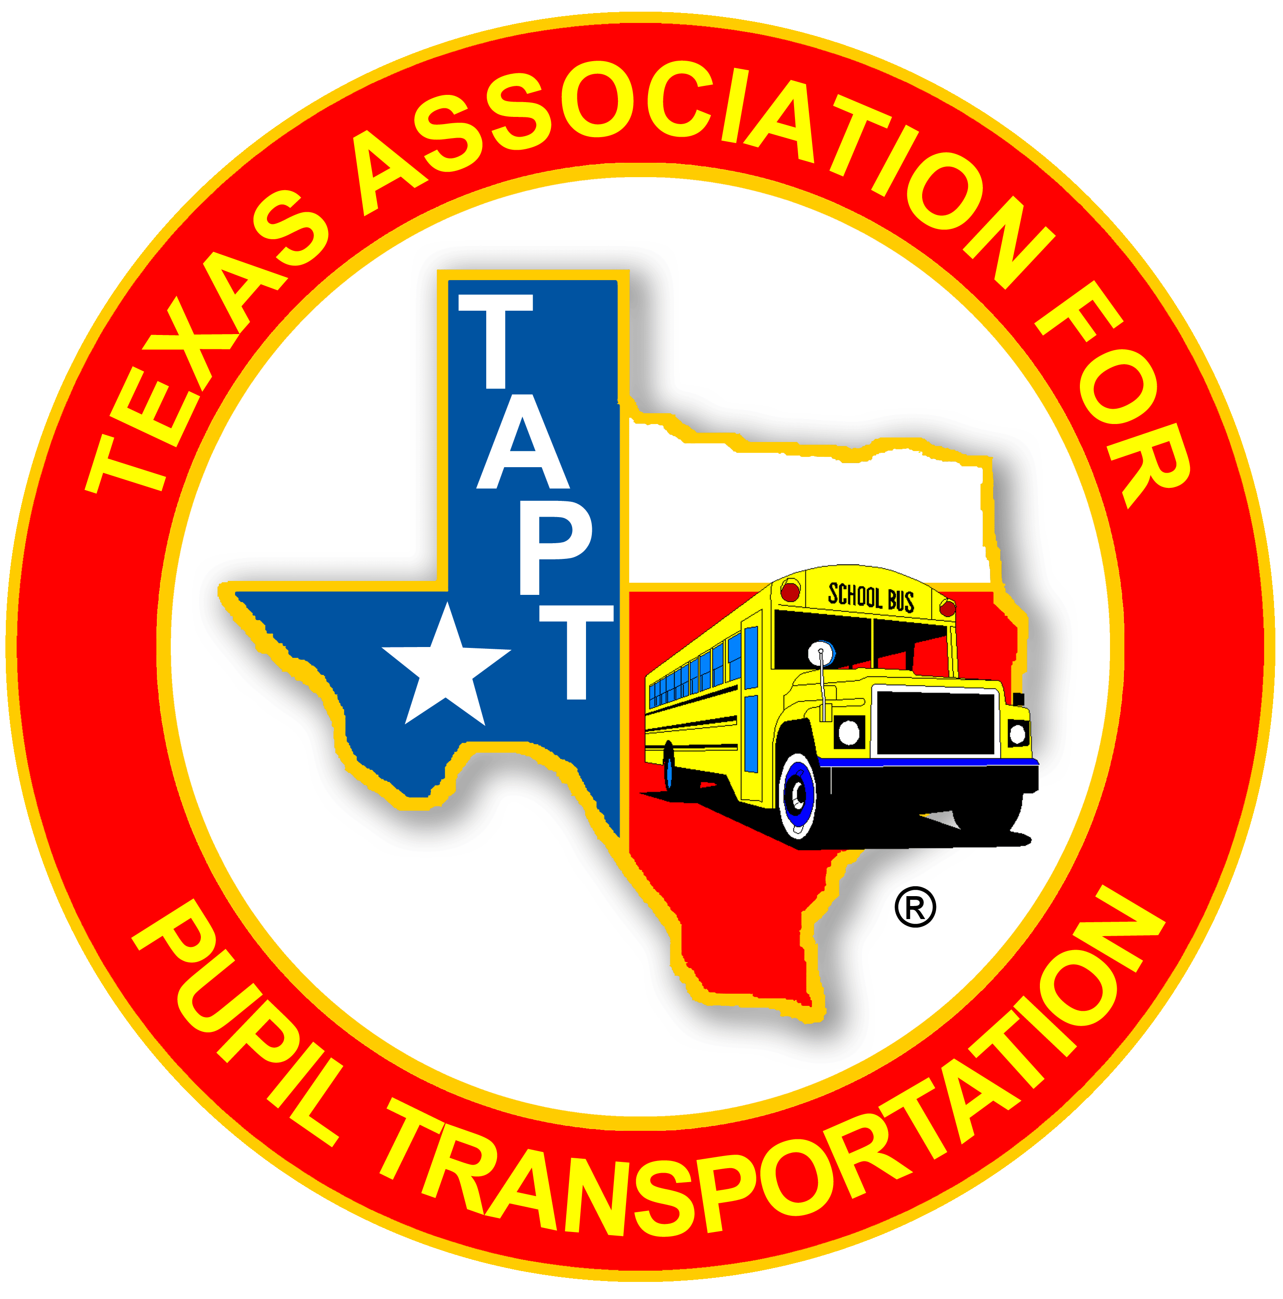

TAPT PDC (number)

Class Title Here

Texas Association for Pupil Transportation
Professional Development and Certification Program
www.TAPT.com Education TAB

Thank you for attending this TAPT Professional Development Course.

For further information regarding TAPT’s Professional Development Courses or Professional Certification Program, please review the TAPT Professional Development Handbook at tapt.com under the Education TAB.

Comments and materials provided are for informational purposes only and not for the purpose of providing legal advice. You should contact your attorney or district administrator to obtain advice with respect to any issue or problem. The opinions expressed during this session and in the materials are the opinions of the individuals and may not reflect the opinions of the Texas Association for Pupil Transportation. (TAPT)

©2024, Texas Association for Pupil Transportation. All rights reserved. No part of these materials may be reproduced, distributed, transmitted, or stored in a retrieval system for commercial purposes without the expressed, written consent of the Texas Association for Pupil Transportation Professional Development Committee.

